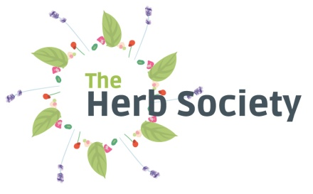

Old Saw Mill, Elizabeth Street, Macclesfield SK11 6QL
info@herbsociety.org.uk : www.herbsociety.org.uk
0845 491 8699

News release – SEPTEMBER 2014

HERB SOCIETY ANNOUNCES TOBY BUCKLAND AS NEW PRESIDENT FOR 2015-16 AND LAUNCHES ITS NEW LOGO.

The Herb Society is delighted to announce that Toby Buckland will take up the role of President from 1 January 2015. His passion for growing and cooking with herbs was clear to see in BBC2’S Great British Garden Revival on Herbs, and he is always on the lookout for new plants and recipes to try as well as new ways of using the herbs that are widely grown. He has written and filmed dozens of pieces on this subject that he calls ‘endlessly fascinating’. He will host two ‘President’s Day’ events for the Herb Society and we look forward to developing a close relationship with him.
Toby Buckland is a qualified horticulturist, TV broadcaster and lifelong gardener. Known for his earthy, hands-on style Toby’s career has taken him from Devon nurseryman to The University of Cambridge Botanic Garden and on to presenting numerous TV shows, including BBC Gardeners’ World. He is an award-winning designer, producing plans for the NHS and 45 Commando Royal Marines and winning RHS Gold and Best in Show at BBC Gardeners’ World Live in 2008. He also lectures and writes for a variety of horticultural journals and newspapers, including The Saturday Telegraph and Mail on Sunday. Recent projects have included BBC2’s Great British Garden Revival on Herbs and the two day ‘Toby Buckland Garden Festival’ at Powderham Castle in Devon which is also the location of his nursery.
The rationale behind the new logo, which was launched at the Herb Society’s AGM on 30 August at RHS Wisley, is to illustrate that herbs are more than just the green leaves available in supermarkets. Herbs are vibrant and amongst other attributes their colourful flowers attract pollinating insects and liven up a green salad – try calendula petals, borage flowers and viola tricolor to stunning effect! To come: the new Herb Society website due shortly.
- ENDS -

Contact: Gwenneth Heyking – 020 8761 6565 – 07721 672348 – garden@gbz.demon.co.uk
www.herbsociety.org.uk
The Herb Society is grateful for generous support from NFU Mutual via its Affiliate Member Scheme

The Society of Herbalists (now The Herb Society) and Culpeper shops were founded in 1927 by Hilda Leyel, a medical herbalist. She practised in rooms above the shops and preparations were made in the shops following the consultation. A fervent believer in the power of herbs to heal, Mrs Leyel was able to continue treating patients between 1941 and 1968, a period when medical herbalism was outlawed by the Pharmacy Act, by offering membership of the Society.

In the 21st century the Herb Society is the only organisation concerned solely with the uses and benefits of herbs whether it be cooking, growing, health, lifestyle or history. It celebrated its 85th anniversary in 2012.

Membership of the Herb Society costs £27 (single) £24.50 (concession) £37 (joint) £42 (family) £40 (overseas)
Join by Direct Debit and get 15 months for the price of 12!

